- This is used to access the work database in the cloud
- SQL Server Management Studio
- We can manipulate data in the local and it can be reflected in the cloud.
- Its a desktop software which is used to manipulate data in the cloud.

- While connecting with the database from the program we need a connection string which can be found in the portal.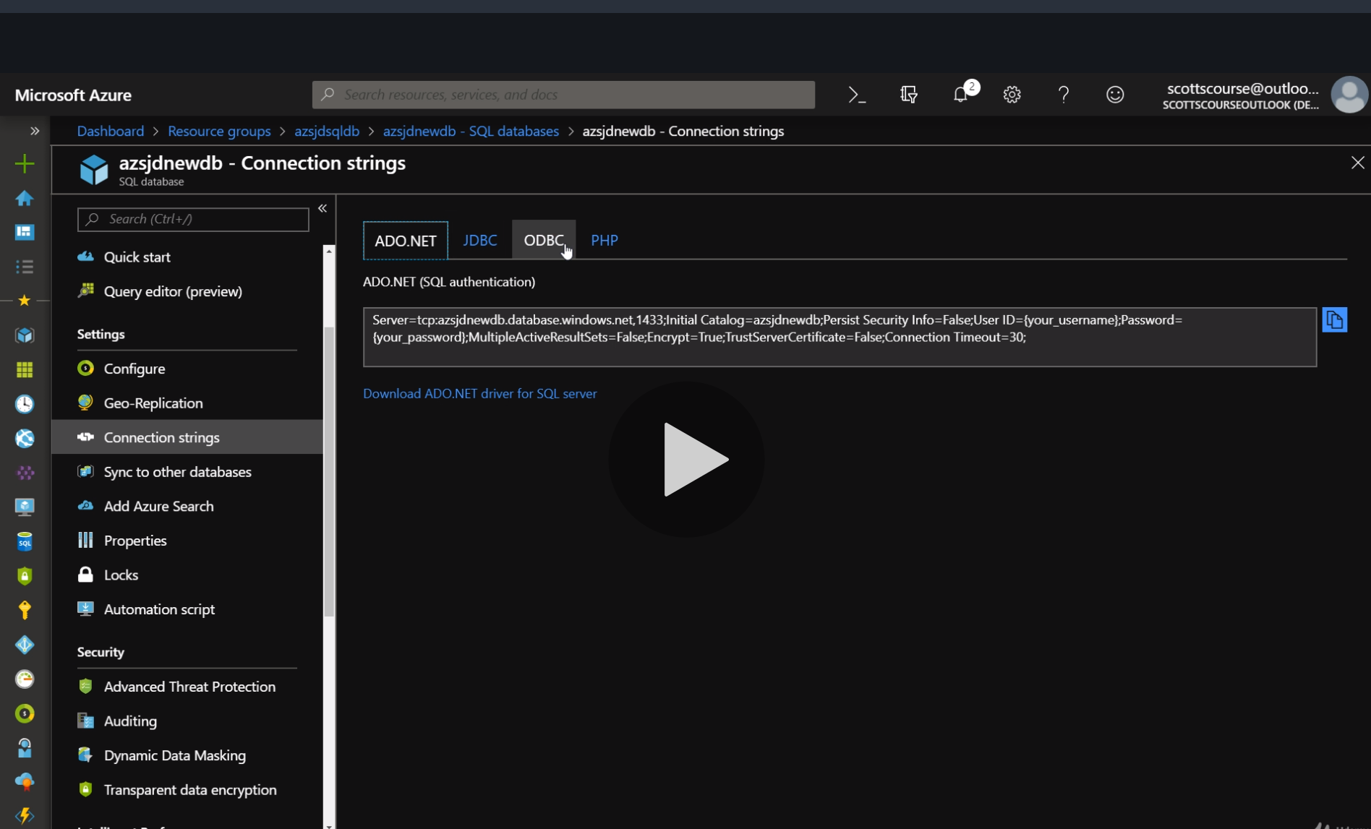
- First the connection is made and then a sql command is run
- 